SAMPLE SQL QUERIES

Creating Database:

Syntax:
create database <Database Name>

Example:
create database Temp

Using Database:

Syntax:
Use <Database Name>

Example:
Use temp

Creating Table:
- The CREATE TABLE statement is used to create a table in a database.

- Tables are organized into rows and columns; and each table must have a name.

Syntax:
CREATE TABLE table_name
(
column_name1 data_type(size),
column_name2 data_type(size),
column_name3 data_type(size),
);

Example:
CREATE TABLE Persons
(
PersonID int,
LastName varchar(255),
FirstName varchar(255),
Address varchar(255),
City varchar(255)
);

Alter Table:

Adding a Column into Existing Table:

Syntax:
alter table tablename add Columnname datatype

Example:
alter table customer add Phoneno varchar(50)

Deleting an Column from an Existing Table:

Syntax
alter table tablename drop column columnname
Example:
alter table customer drop column Phoneno

Changing the Datatype of the Column:

Syntax:
alter table tablename alter column columnname int

Example
alter table customer alter column city int

Deleting an Column from an Existing Table:

Syntax:
alter table tablename drop column columnname
Example:
alter table customer drop column Phoneno

Changing the Datatype of the Column:

Syntax:
alter table tablename alter column columnname int

Example:
alter table customer alter column city int

Delete table:

Syntax:
Drop table tablename

Example:
Drop table customer

Inserting values into Tables:

Syntax:
INSERT INTO table_name VALUES (value1,value2,value3,...);
Example:
insert into Customer values (1,'Raju','Chennai');

Inserting Values for Selected Columns:

Syntax:
INSERT INTO table_name (column1,column2,column3,...) VALUES (value1,value2,value3,...);

Example:
insert into Customer (cno,CustomerName ) values(3,'Ram')

Selecting Records with Where Class:

Syntax:
Select column name, colum name from table name where column name operator value;

Example:
SELECT * FROM Customers WHERE Country='Mexico';

Selection with Multiple Conditions:

Select * from Customer where Country='Mexico' and id=1;

Operators:

Operator | Description
= | Equal
<> | Not equal. Note: In some versions of SQL this operator  may be written as !=
> | Greater than
< | Less than
>= | Greater than or equal
<= | Less than or equal
BETWEEN | Between an inclusive range
LIKE | Search for a pattern
IN | To specify multiple possible values for a column

And Operator:

SELECT * FROM Customers WHERE Country='Germany' AND City='Berlin';

OR Operator:
SELECT * FROM Customers WHERE City='Berlin' OR City='München';

Both AND and OR:
SELECT * FROM Customers WHERE Country='Germany' AND (City='Berlin' OR City=”Munich”);

Selecting Distinct Values:

Syntax:
SELECT DISTINCT column_name,column_name FROM table_name;

Example:
SELECT DISTINCT City FROM Customers;

Ordering the Selected values:

Syntax:
SELECT column_name,column_name FROM table_name ORDER BY column_name,column_name ASC|DESC;

Example:
SELECT * FROM Customers ORDER BY Country;

Sorting the Values in descending Values:

SELECT * FROM Customers ORDER BY Country DESC;

Sorting the values with Multiple Columns:

SELECT * FROM Customers ORDER BY Country,CustomerName;

Updating a Record in a Table:

Syntax:
UPDATE table_name SET column1=value1,column2=value2,... WHERE some_column=some_value;

Example:
UPDATE Customers
SET ContactName='Alfred Schmidt', City='Hamburg'
WHERE CustomerName='Alfreds Futterkiste';

Updating a particular Record:

UPDATE Customers SET ContactName='Alfred Schmidt', City='Hamburg'
WHERE CustomerName='Alfreds Futterkiste';

Updating Every Record:

UPDATE Customers SET ContactName='Alfred Schmidt', City='Hamburg';

Deleting Values from Table:

Syntax:
DELETE FROM table_name WHERE some_column=some_value;

Example:
DELETE FROM Customers WHERE CustomerName='Alfreds Futterkiste';

SQL Top Clause :

Syntax:
SELECT TOP number|percent column_name(s) FROM table_name;

Example:
Selects first two records:
SELECT TOP 2 * FROM Customers;

Like Operator:

The LIKE operator is used in a WHERE clause to search for a specified pattern in a column.
Syntax:
SELECT column_name(s) FROM table_name WHERE column_name LIKE pattern;

Example:
SELECT * FROM Customers WHERE City LIKE 's%';

The following SQL statement selects all customers with a Country containing the pattern "land"
SELECT * FROM Customers WHERE Country LIKE '%land%';

The following SQL statement selects all customers with a City starting with "b", "s", or "p"
SELECT * FROM CustomersWHERE City LIKE '[bsp]%';

The following SQL statement selects all customers with a City starting with "a", "b", or "c"
SELECT * FROM Customers WHERE City LIKE '[a-c]%';

In Operator:

The IN operator allows you to specify multiple values in a WHERE clause

Syntax:
SELECT column_name(s) FROM table_name WHERE column_name IN (value1,value2,...);

Example:
SELECT * FROM Customers WHERE City IN ('Paris','London');

Between operator:
BETWEEN operator selects values within a range.

Syntax:
SELECT column_name(s) FROM table_name WHERE column_name BETWEEN value1 AND value2;

Example:
Selects all products with a price BETWEEN 10 and 20
SELECT * FROM Products WHERE Price BETWEEN 10 AND 20;

Selects all products with a ProductName beginning with any of the letter BETWEEN 'C' and 'M'
SELECT * FROM Products WHERE ProductName BETWEEN 'C' AND 'M';

SQL Aliases

SQL Alias Syntax for Columns:

SELECT column_name AS alias_name FROM table_name;

SQL Alias Syntax for Tables:

SELECT column_name(s) FROM table_name AS alias_name;

Example:
One for the CustomerName column and one for the ContactName column.
SELECT CustomerName AS Customer, ContactName AS [Contact Person]
FROM Customers;

Alias for Table:

SELECT o.OrderID, o.OrderDate, c.CustomerName FROM Customers AS c, Orders AS o WHERE c.CustomerName="Around the Horn" AND c.CustomerID=o.CustomerID;

SQL JOIN
SQL JOIN clause is used to combine rows from two or more tables, based on a common field between them.

Union operator:

UNION operator is used to combine the result-set of two or more SELECT statements.
Syntax:
SELECT column_name(s) FROM table1
UNION
SELECT column_name(s) FROM table2;

Example:
SELECT City FROM Customers
UNION
SELECT City FROM Suppliers ORDER BY City;

Union All:

Syntax:
SELECT column_name(s) FROM table1
UNION ALL
SELECT column_name(s) FROM table2;

Example:
SELECT City FROM Customers
UNION ALL
SELECT City FROM Suppliers
ORDER BY City;

SELECT INTO Statement
SELECT INTO statement copies data from one table and inserts it into a new table.

Syntax:
SELECT * INTO newtable [IN externaldb] FROM table1;

Example:
SELECT * INTO CustomersBackup2013 FROM Customers

IN clause to copy the table into another database
SELECT *
INTO CustomersBackup2013 IN 'Backup.mdb'
FROM Customers;

SQL INSERT INTO SELECT
Copy all columns from one table to another, existing table
Syntax:
INSERT INTO table2 SELECT * FROM table1;

Example:
INSERT INTO Customers (CustomerName, Country)
SELECT SupplierName, Country FROM Suppliers;

SQL Constraints
- NOT NULL - Indicates that a column cannot store NULL value
- UNIQUE - Ensures that each row for a column must have a unique value
- PRIMARY KEY - A combination of a NOT NULL and UNIQUE. Ensures that a column (or combination of two or more columns) have an unique identity which helps to find a particular record in a table more easily and quickly
- FOREIGN KEY - Ensure the referential integrity of the data in one table to match values in another table
- CHECK - Ensures that the value in a column meets a specific condition
- DEFAULT - Specifies a default value when specified none for this column

Not Null:
Example:
CREATE TABLE PersonsNotNull
(
P_Id int NOT NULL,
LastName varchar(255) NOT NULL,
FirstName varchar(255),
Address varchar(255),
City varchar(255)
)

Unique:
Example:
CREATE TABLE Persons
(
P_Id int NOT NULL UNIQUE,
LastName varchar(255) NOT NULL,
FirstName varchar(255),
Address varchar(255),
City varchar(255)
)

Primary Key:
Example:
CREATE TABLE Persons
(
P_Id int NOT NULL PRIMARY KEY,
LastName varchar(255) NOT NULL,
FirstName varchar(255),
Address varchar(255),
City varchar(255)
)

Foreign Key:
Example:
CREATE TABLE Orders
(
O_Id int NOT NULL PRIMARY KEY,OrderNo int NOT NULL,
P_Id int FOREIGN KEY REFERENCES Persons(P_Id)
)

Altering Constraints:
Example:
ALTER TABLE Orders
ADD FOREIGN KEY (P_Id)
REFERENCES Persons(P_Id)

Auto Increment :
Example:
CREATE TABLE Persons
(
ID int IDENTITY(1,1) PRIMARY KEY,
LastName varchar(255) NOT NULL,
FirstName varchar(255),
Address varchar(255),
City varchar(255)
)
Auto-increment allows a unique number to be generated when a new record is inserted into a table.

Views:

A view is a virtual table

Syntax:

CREATE VIEW view_name AS SELECT column_name(s) FROM table_name WHERE condition

Example:

CREATE VIEW view_name AS SELECT column_name(s) FROM table_name WHERE conditionCREATE VIEW [Current Product List] AS

SELECT ProductID,ProductName

FROM Products

WHERE Discontinued=N

Dropping a View

Deletes/ drops the view specified

Syntax:

DROP VIEW view_name

Indexes
An index can be created in a table to find data more quickly and efficiently.

Syntax:

CREATE INDEX index_name ON table_name (column_name)

Example:

CREATE INDEX PIndex ON Persons (LastName)

Functions:

AVG()

Syntax:

SELECT AVG(column_name) FROM table_name

Example:
SELECT AVG(Price) AS PriceAverage FROM Products;

COUNT() Function:
The COUNT(column_name) function returns the number of values (NULL values will not be counted) of the specified column:

Syntax:

SELECT COUNT(column_name) FROM table_name;

Example:
SELECT COUNT(CustomerID) AS OrdersFromCustomerID7 FROM Orders
WHERE CustomerID=7;

SQL FIRST() Syntax
The FIRST() function returns the first value of the selected column.

Syntax:
SELECT TOP 1 column_name FROM table_name ORDER BY column_name ASC;

Example:
SELECT top 1 * FROM Customers;

MAX() Function:
The MAX() function returns the largest value of the selected column.

SQL MAX() Syntax:

SELECT MAX(column_name) FROM table_name;

MIN() Function:
The MIN() function returns the smallest value of the selected column.

SQL MIN() Syntax:

SELECT MIN(column_name) FROM table_name;

SUM() Function:
The SUM() function returns the total sum of a numeric column.

SQL SUM() Syntax:

SELECT SUM(column_name) FROM table_name;

GROUP BY Statement:
The GROUP BY statement is used in conjunction with the aggregate functions to group the result-set by one or more columns.

SQL GROUP BY Syntax:

SELECT column_name, aggregate_function(column_name)

FROM table_name

WHERE column_name operator value

GROUP BY column_name;

HAVING Clause
The HAVING clause was added to SQL because the WHERE keyword could not be used with aggregate functions.

SQL HAVING Syntax

SELECT column_name, aggregate_function(column_name)

FROM table_name

WHERE column_name operator value

GROUP BY column_name

HAVING aggregate_function(column_name) operator value;

Triggers:

Insert Tirgger:
create trigger InsertTrigger
on Customer after insert
as
begin
declare @cno int
--Setting values for varaibles
--@set sno=10
select @cno=cno from inserted
insert into CustomerCopy(cno) values ( @cno )
end

Triggers with Conditions :
alter trigger DeleteTrigger
on Customer after insert
as
begin
declare @cno int
--Setting values for varaibles
--@set sno=10
select @cno=cno from inserted
if (@cno > 10)
begin
insert into CustomerCopy(cno,CustomerName ) values ( @cno,'Customer No Above 10' )
end
else
begin
insert into CustomerCopy(cno,CustomerName ) values ( @cno,'Customer No Lessthan 10' )
end
end

Hint:
alter trigger DeleteTrigger
on Customer after insert /Delete/Update as
Tablename – insert/Update: inserted
Tablename – delete: deleted

Different Types of SQL Server Function
Function is a database object in Sql Server. Basically it is a set of sql statements that accepts only input parameters, perform actions and return the result. Function can return only single value or a table. We can’t use function to Insert, Update, Delete records in the database table(s). For more about stored procedure and function refer the article Difference between Stored Procedure and Function

Types of Function:
01.System Defined Function
These functions are defined by Sql Server for different purpose. We have two types of system defined function in Sql Server.

- Scalar Function:
Scalar functions operates on a single value and returns a single value. Below is the list of some useful Sql Server Scalar functions.

Scalar Function | Description
abs(-10.67) | This returns absolute number of the given number means 10.67.
rand(10) | This will generate random number of 10 characters.
round(17.56719,3) | This will round off the given number to 3 places of decimal means 17.567
upper('dotnet') | This will returns upper case of given string means 'DOTNET'
lower('DOTNET') | This will returns lower case of given string means 'dotnet'
ltrim(' dotnet') | This will remove the spaces from left hand side of 'dotnet' string.
convert(int, 15.56) | This will convert the given float value to integer means 15.
- Aggregate Function

Aggregate functions operates on a collection of values and returns a single value.
Below is the list of some useful Sql Server Aggregate functions.
Aggregate Function | Description
max() | This returns maximum value from a collection of values.
min() | This returns minimum value from a collection of values.
avg() | This returns average of all values in a collection.
count() | This returns no of counts from a collection of values.

02.User Defined Function
These functions are created by user in system database or in user defined database. We three types of user defined functions.

- Scalar Function
User defined scalar function also returns single value as a result of actions perform by function. We return any datatype value from function.

Example:

Create a table
CREATE TABLE Employee ( EmpID int PRIMARY KEY, FirstName varchar(50) NULL, LastName varchar(50) NULL, Salary int NULL, Address varchar(100) NULL, )
Insert Data
Insert into Employee(EmpID,FirstName,LastName,Salary,Address) Values(1,'Mohan','Chauahn',22000,'Delhi');

Insert into Employee(EmpID,FirstName,LastName,Salary,Address) Values(2,'Asif','Khan',15000,'Delhi');
Insert into Employee(EmpID,FirstName,LastName,Salary,Address) Values(3,'Bhuvnesh','Shakya',19000,'Noida');

Insert into Employee(EmpID,FirstName,LastName,Salary,Address) Values(4,'Deepak','Kumar',19000,'Noida');

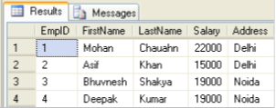

Create function to get employee full name
Create function fnGetEmpFullName ( @FirstName varchar(50), @LastName varchar(50) ) returns varchar(101) As Begin return (Select @FirstName + ' '+ @LastName);
end

Calling the above created function
Select dbo.fnGetEmpFullName(FirstName,LastName) as Name, Salary from Employee

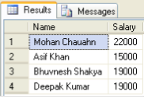

03.Inline Table-Valued Function
User defined inline table-valued function returns a table variable as a result of actions perform by function. The value of table variable should be derived from a single SELECT statement.

Create function to get employees
Create function fnGetEmployee() returns Table As return (Select * from Employee)

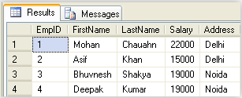

03.Multi-Statement Table-Valued Function
User defined multi-statement table-valued function returns a table variable as a result of actions perform by function. In this a table variable must be explicitly declared and defined whose value can be derived from a multiple sql statements.
Create function for EmpID, FirstName and Salary of Employee
Create function fnGetMulEmployee()
returns @Emp Table
(EmpID int, FirstName varchar(50),Salary int)As begin Insert into @Emp Select e.EmpID,e.FirstName,e.Salary from Employee e;

Now update salary of first employee
update @Emp set Salary=25000 where EmpID=1;
//It will update only in @Emp table not in Original Employee table
return
end

Now call the above created function

Select * from fnGetMulEmployee()

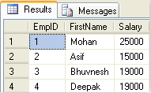

//Now see the original table. This is not affected by above function update command
Select * from Employee
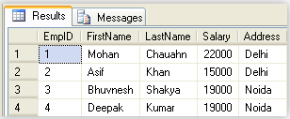

Note
- Unlike Stored Procedure, Function returns only single value.
- Unlike Stored Procedure, Function accepts only input parameters.
- Unlike Stored Procedure, Function is not used to Insert, Update, Delete data in database table(s).
- Like Stored Procedure, Function can be nested up to 32 level.
- User Defined Function can have upto 1023 input parameters while a Stored Procedure can have upto 2100 input parameters.
- User Defined Function can't returns XML Data Type.
- User Defined Function doesn't support Exception handling.
- User Defined Function can call only Extended Stored Procedure.
- User Defined Function doesn't support set options like set ROWCOUNT etc.

SQL JOIN
An SQL JOIN clause is used to combine rows from two or more tables, based on a common field between them.
The most common type of join is: SQL INNER JOIN (simple join). An SQL INNER JOIN return all rows from multiple tables where the join condition is met.

Let's look at a selection from the "Orders" table:

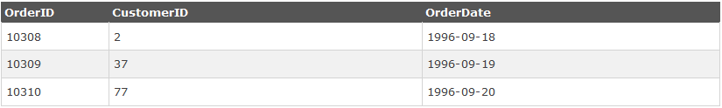

Then, have a look at a selection from the "Customers" table:

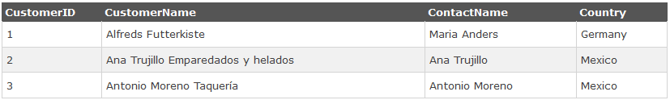

Notice that the "CustomerID" column in the "Orders" table refers to the customer in the "Customers" table. The relationship between the two tables above is the "CustomerID" column.
Then, if we run the following SQL statement (that contains an INNER JOIN):

Example:
SELECT Orders.OrderID, Customers.CustomerName, Orders.OrderDate
FROM Orders
INNER JOIN Customers
ON Orders.CustomerID=Customers.CustomerID;

it will produce something like this:
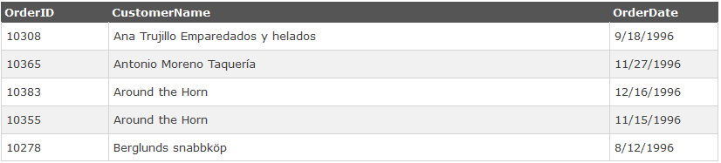

Different SQL JOINs
Before we continue with examples, we will list the types the different SQL JOINs you can use:
- INNER JOIN: Returns all rows when there is at least one match in BOTH tables
- LEFT JOIN: Return all rows from the left table, and the matched rows from the right table
- RIGHT JOIN: Return all rows from the right table, and the matched rows from the left table
- FULL JOIN: Return all rows when there is a match in ONE of the tables

SQL INNER JOIN Keyword
The INNER JOIN keyword selects all rows from both tables as long as there is a match between the columns in both tables.

SQL INNER JOIN Syntax
SELECT column_name(s)
FROM table1
INNER JOIN table2
ON table1.column_name=table2.column_name;
or:
SELECT column_name(s)
FROM table1
JOIN table2
ON table1.column_name=table2.column_name;
PS! INNER JOIN is the same as JOIN.
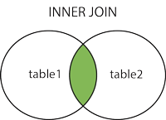

Demo Database
In this tutorial we will use the well-known Northwind sample database.
Below is a selection from the "Customers" table:
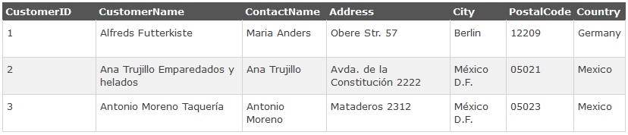
And a selection from the "Orders" table:
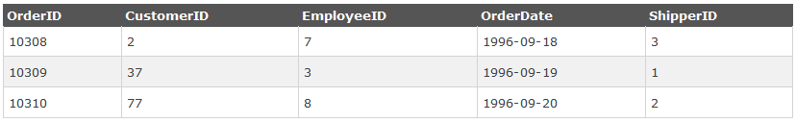

SQL INNER JOIN Example
The following SQL statement will return all customers with orders:

Example:

SELECT Customers.CustomerName, Orders.OrderID
FROM Customers
INNER JOIN Orders
ON Customers.CustomerID=Orders.CustomerID
ORDER BY Customers.CustomerName;

Note:
The INNER JOIN keyword selects all rows from both tables as long as there is a match between the columns. If there are rows in the "Customers" table that do not have matches in "Orders", these customers will NOT be listed.

SQL LEFT JOIN Keyword
The LEFT JOIN keyword returns all rows from the left table (table1), with the matching rows in the right table (table2). The result is NULL in the right side when there is no match.

SQL LEFT JOIN Syntax

Example:
SELECT column_name(s)
FROM table1
LEFT JOIN table2
ON table1.column_name=table2.column_name ;

Or
SELECT column_name(s)
FROM table1
LEFT OUTER JOIN table2
ON table1.column_name=table2.column_name ;

PS! In some databases LEFT JOIN is called LEFT OUTER JOIN.
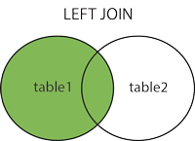

Demo Database
In this tutorial we will use the well-known Northwind sample database.
Below is a selection from the "Customers" table:
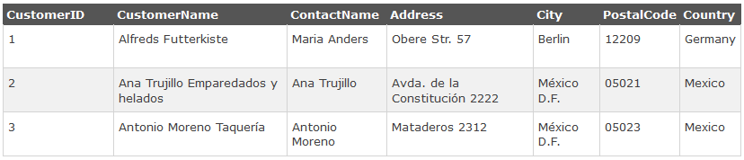
And a selection from the "Orders" table:
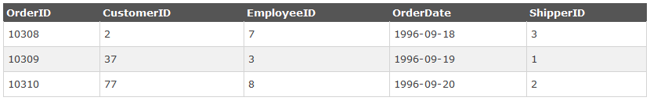

SQL LEFT JOIN Example
The following SQL statement will return all customers, and any orders they might have:

Example:
SELECT Customers.CustomerName, Orders.OrderID
FROM Customers
LEFT JOIN Orders
ON Customers.CustomerID=Orders.CustomerID
ORDER BY Customers.CustomerName;

Note:
The LEFT JOIN keyword returns all the rows from the left table (Customers), even if there are no matches in the right table (Orders).

SQL RIGHT JOIN Keyword
The RIGHT JOIN keyword returns all rows from the right table (table2), with the matching rows in the left table (table1). The result is NULL in the left side when there is no match.

SQL RIGHT JOIN Syntax

SELECT column_name(s)
FROM table1
RIGHT JOIN table2
ON table1.column_name=table2.column_name ;
Or
SELECT column_name(s)
FROM table1
RIGHT OUTER JOIN table2
ON table1.column_name=table2.column_name ;

PS! In some databases RIGHT JOIN is called RIGHT OUTER JOIN.
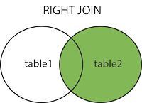

Demo Database
In this tutorial we will use the well-known Northwind sample database.
Below is a selection from the "Orders" table:

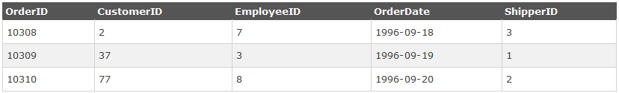
And a selection from the "Employees" table:
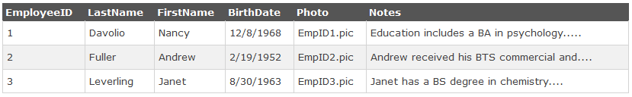

SQL RIGHT JOIN Example
The following SQL statement will return all employees, and any orders they have placed:

Example:
SELECT Orders.OrderID, Employees.FirstName
FROM Orders
RIGHT JOIN Employees
ON Orders.EmployeeID=Employees.EmployeeID
ORDER BY Orders.OrderID;

Note:
The RIGHT JOIN keyword returns all the rows from the right table (Employees), even if there are no matches in the left table (Orders).

SQL FULL OUTER JOIN Keyword
The FULL OUTER JOIN keyword returns all rows from the left table (table1) and from the right table (table2).
The FULL OUTER JOIN keyword combines the result of both LEFT and RIGHT joins.

SQL FULL OUTER JOIN Syntax

SELECT column_name(s)
FROM table1
FULL OUTER JOIN table2
ON table1.column_name=table2.column_name;
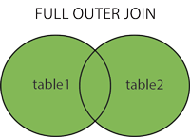

Demo Database
In this tutorial we will use the well-known Northwind sample database.
Below is a selection from the "Customers" table:

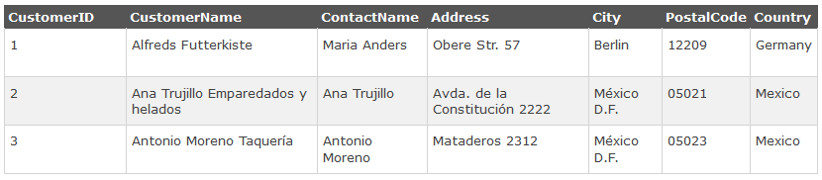

A selection from the result set may look like this:
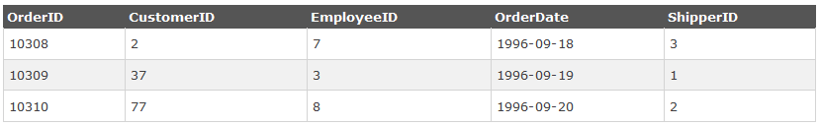

SQL FULL OUTER JOIN Example
The following SQL statement selects all customers, and all orders:
SELECT Customers.CustomerName, Orders.OrderID
FROM Customers
FULL OUTER JOIN Orders
ON Customers.CustomerID=Orders.CustomerID
ORDER BY Customers.CustomerName;

A selection from the result set may look like this:
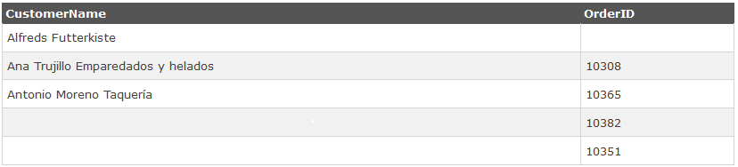

Note:
The FULL OUTER JOIN keyword returns all the rows from the left table (Customers), and all the rows from the right table (Orders). If there are rows in "Customers" that do not have matches in "Orders", or if there are rows in "Orders" that do not have matches in "Customers", those rows will be listed as well.

The SQL UNION Operator
The UNION operator is used to combine the result-set of two or more SELECT statements.
Notice that each SELECT statement within the UNION must have the same number of columns. The columns must also have similar data types. Also, the columns in each SELECT statement must be in the same order.

SQL UNION Syntax
SELECT column_name(s) FROM table1
UNION
SELECT column_name(s) FROM table2;

Note:
The UNION operator selects only distinct values by default. To allow duplicate values, use the ALL keyword with UNION.

SQL UNION ALL Syntax
SELECT column_name(s) FROM table1
UNION ALL
SELECT column_name(s) FROM table2;

PS: The column names in the result-set of a UNION are usually equal to the column names in the first SELECT statement in the UNION.

Demo Database
In this tutorial we will use the well-known Northwind sample database.
Below is a selection from the "Customers" table:
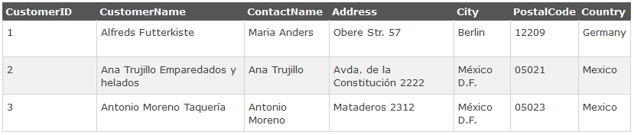
And a selection from the "Suppliers" table:
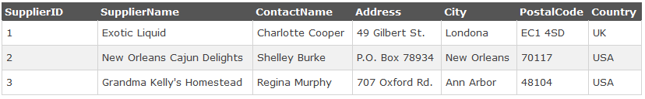

SQL UNION Example
The following SQL statement selects all the different cities (only distinct values) from the "Customers" and the "Suppliers" tables:

Example:
SELECT City FROM Customers
UNION
SELECT City FROM Suppliers
ORDER BY City;

Note:
UNION cannot be used to list ALL cities from the two tables. If several customers and suppliers share the same city, each city will only be listed once. UNION selects only distinct values. Use UNION ALL to also select duplicate values!

SQL UNION ALL Example
The following SQL statement uses UNION ALL to select all (duplicate values also) cities from the "Customers" and "Suppliers" tables:
Example:
SELECT City FROM Customers
UNION ALL
SELECT City FROM Suppliers
ORDER BY City;

SQL UNION ALL With WHERE
The following SQL statement uses UNION ALL to select all (duplicate values also) German cities from the "Customers" and "Suppliers" tables:
Example:
SELECT City, Country FROM Customers
WHERE Country='Germany'
UNION ALL
SELECT City, Country FROM Suppliers
WHERE Country='Germany'
ORDER BY City;

Triggers:
Triggers are stored programs, which are automatically executed or fired when some events occur. Triggers are, in fact, written to be executed in response to any of the following events:
- A database manipulation (DML) statement (DELETE, INSERT, or UPDATE).
- A database definition (DDL) statement (CREATE, ALTER, or DROP).
- A database operation (SERVERERROR, LOGON, LOGOFF, STARTUP, or SHUTDOWN).
Triggers could be defined on the table, view, schema, or database with which the event is associated.

Benefits of Triggers
Triggers can be written for the following purposes:
- Generating some derived column values automatically
- Enforcing referential integrity
- Event logging and storing information on table access
- Auditing
- Synchronous replication of tables
- Imposing security authorizations
- Preventing invalid transactions

Creating Triggers
The syntax for creating a trigger is:

CREATE [OR REPLACE ] TRIGGER trigger_name
{BEFORE | AFTER | INSTEAD OF }
{INSERT [OR] | UPDATE [OR] | DELETE}
[OF col_name]
ON table_name
[REFERENCING OLD AS o NEW AS n]
[FOR EACH ROW]
WHEN (condition)
DECLARE
Declaration-statements
BEGIN
Executable-statements
EXCEPTION
Exception-handling-statements
END;

Where,
- CREATE [OR REPLACE] TRIGGER trigger_name: Creates or replaces an existing trigger with the trigger_name.
- {BEFORE | AFTER | INSTEAD OF} : This specifies when the trigger would be executed. The INSTEAD OF clause is used for creating trigger on a view.
- {INSERT [OR] | UPDATE [OR] | DELETE}: This specifies the DML operation.
- [OF col_name]: This specifies the column name that would be updated.
- [ON table_name]: This specifies the name of the table associated with the trigger.
- [REFERENCING OLD AS o NEW AS n]: This allows you to refer new and old values for various DML statements, like INSERT, UPDATE, and DELETE.
- [FOR EACH ROW]: This specifies a row level trigger, i.e., the trigger would be executed for each row being affected. Otherwise the trigger will execute just once when the SQL statement is executed, which is called a table level trigger.
- WHEN (condition): This provides a condition for rows for which the trigger would fire. This clause is valid only for row level triggers.

Example:
To start with, we will be using the CUSTOMERS table we had created and used in the previous chapters:
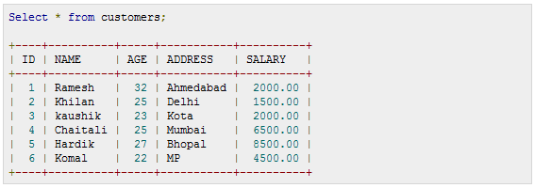

The following program creates a row level trigger for the customers table that would fire for INSERT or UPDATE or DELETE operations performed on the CUSTOMERS table. This trigger will display the salary difference between the old values and new values:
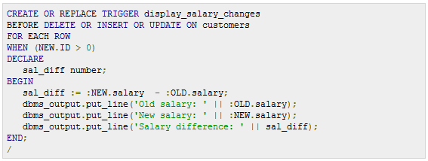

When the above code is executed at SQL prompt, it produces the following result:
Here following two points are important and should be noted carefully:
- OLD and NEW references are not available for table level triggers, rather you can use them for record level triggers.
- If you want to query the table in the same trigger, then you should use the AFTER keyword, because triggers can query the table or change it again only after the initial changes are applied and the table is back in a consistent state.
- Above trigger has been written in such a way that it will fire before any DELETE or INSERT or UPDATE operation on the table, but you can write your trigger on a single or multiple operations, for example BEFORE DELETE, which will fire whenever a record will be deleted using DELETE operation on the table.

Triggering a Trigger
Let us perform some DML operations on the CUSTOMERS table. Here is one INSERT statement, which will create a new record in the table:

When a record is created in CUSTOMERS table, above create trigger display_salary_changes will be fired and it will display the following result:
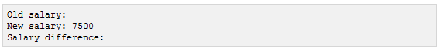
Because this is a new record so old salary is not available and above result is coming as null. Now, let us perform one more DML operation on the CUSTOMERS table. Here is one UPDATE statement, which will update an existing record in the table:
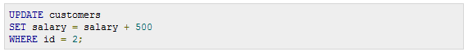
When a record is updated in CUSTOMERS table, above create trigger display_salary_changes will be fired and it will display the following result:
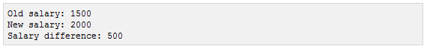

References:
www.w3schools.com

